**SODIUM SULFATE**

**HERO**

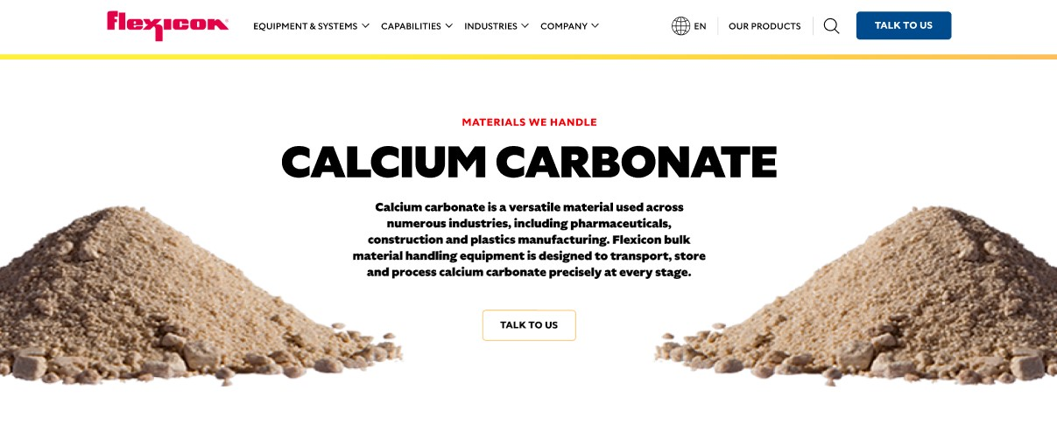Sodium sulfate is a versatile compound used in industries ranging from glass and textiles to electronics recycling. Flexicon bulk material handling equipment is engineered to move, store, and process sodium sulfate efficiently and safely at every stage.

**Button**: Talk To Us

**SHELF #1 - PRODUCT DESCRIPTION**

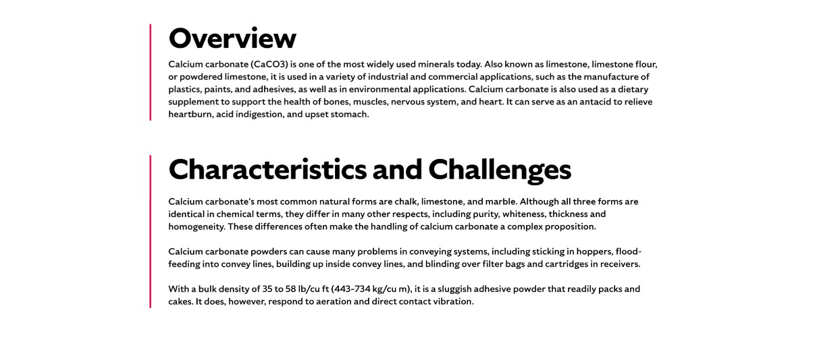

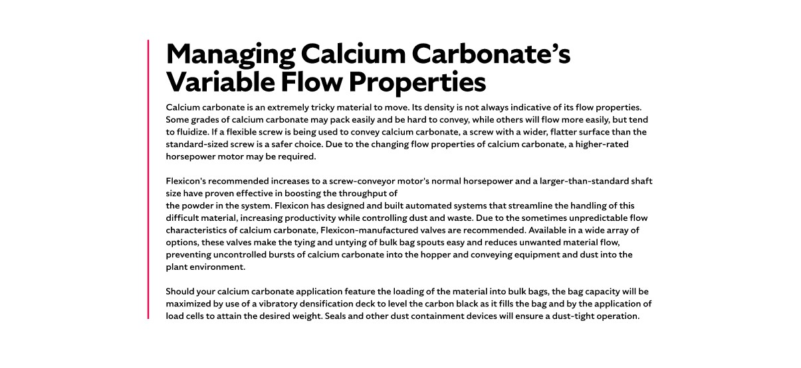

**Overview**

Historically known as “Miraculous Salt,” sodium sulfate has evolved from medicinal use to industrial applications. It is widely used as a filler and leveling agent in glass manufacturing, textile production, and increasingly in gold recovery from electronics. While its role in detergents and paper has declined due to regulatory changes, sodium sulfate remains a valuable material. Most global production comes from natural sources like mirabilite, though it is also recovered as a byproduct from chemical processes.

**Characteristics and Challenges**Sodium sulfate is typically free-flowing, crystalline, and dense, with an average bulk density of 85 lb/cu ft. It is also abrasive and hygroscopic, meaning it absorbs moisture from the air, which can affect flowability. Its granular nature makes it suitable for round screw designs in flexible screw conveyors.

Due to its abrasive and moisture-sensitive properties, sodium sulfate requires rugged, well-sealed conveying systems. Improper handling can lead to clumping, equipment wear, and flow disruptions, especially in humid environments.

**SHELF #2 - FLEXICON SOLUTIONS**

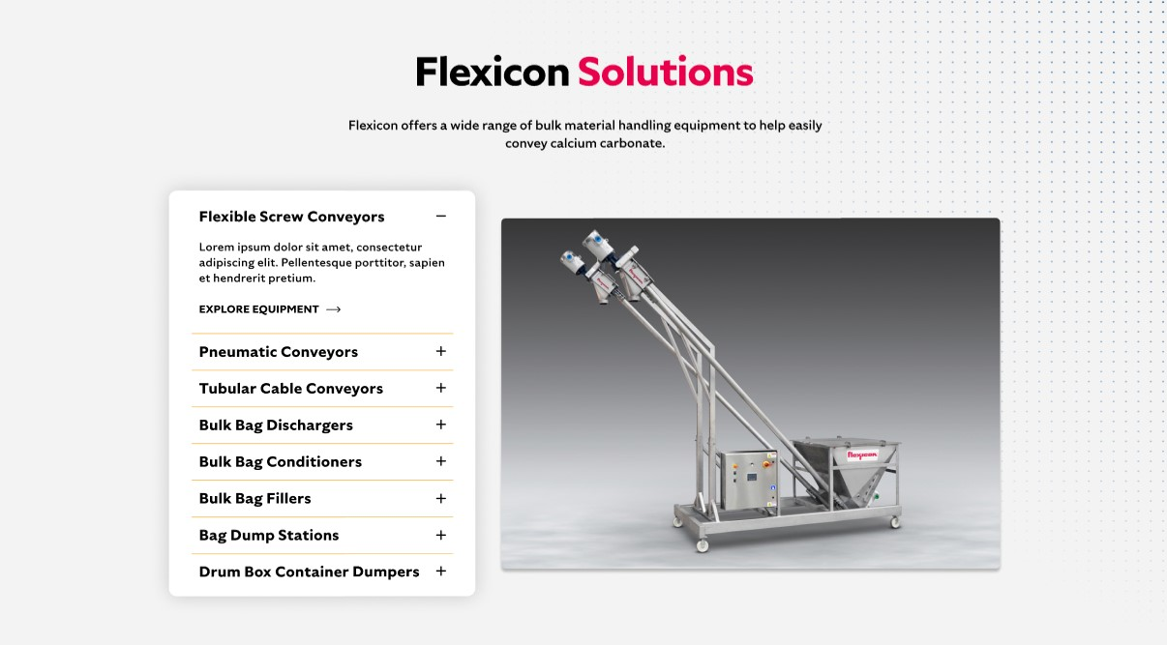

**Flexicon Solutions**

Flexicon offers a wide range of bulk material handling equipment to help easily convey sodium sulfate.

**Flexible Screw Conveyors:** Transport dense, granular sodium sulfate with screw designs optimized for free-flowing materials.

**Pneumatic Conveyors:** Provide enclosed, dust-free transfer with filtration and moisture control for hygroscopic sodium sulfate.

**Tubular Cable Conveyors:** Offer enclosed, space-efficient routing ideal for crystalline sodium sulfate in compact layouts.

**Bulk Bag Dischargers:** Enable safe, dust-tight unloading of sodium sulfate from bulk bags with flow-assist accessories.

**Bulk Bag Conditioners:** Break up compacted sodium sulfate to restore consistent flow during discharge.

**Bulk Bag Fillers:** Accurately fill bulk bags with sodium sulfate while minimizing dust and ensuring weight precision.

**Bag Dump Stations:** Support manual unloading of sodium sulfate with integrated dust collection and operator protection.

**Drum/Box/Container Dumpers:** Safely transfer sodium sulfate from smaller containers into processing systems with minimal dust and manual effort.

**SHELF #3: LIFETIME PERFORMANCE GUARANTEE**

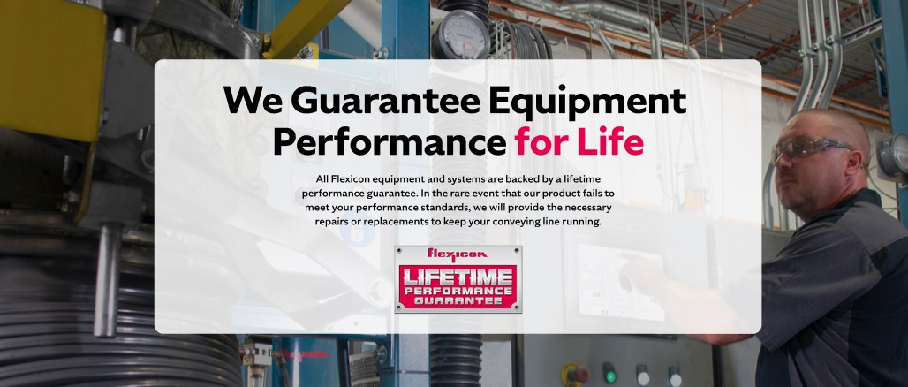

**Lifetime Performance Guarantee**

All Flexicon equipment and systems are backed by a lifetime performance guarantee. In the rare event that our product fails to meet your performance standards, we will provide the necessary repairs or replacements to keep your conveying line running.

**SHELF #4: CASE STUDIES**

